**SOFTWARE DEVELOPMENT PROJECT**

**SCCI/00616/2021**

**BRIAN KANOTI**

**TITLE: THE MEAL PLANNING SYSTEM**

**Description:** Create an app that allows users to plan their meals for the week and generate a grocery list based on their meal plan. The app could suggest recipes based on dietary restrictions and preferences, and allow users to save their favorite recipes.

**Problem:** As human beings, it is obvious that we are prone to wasting time. Many people so much time trying to find out what meal they should take on that particular time. It is necessary that we have this app as it will be sending us a reminder to our phones minutes before the time of the meal and the proper ingredients that will be needed to prepare it.

UML diagram

|  |  |  |
| --- | --- | --- |
| Symbol | Symbol Name | Purpose |
|  | Start/Stop | Used at the beginning and end of the algorithm to show the start and end of the program. |
|  | Process | Indicates processes like mathematical operations. |
|  | Input/ Output | Used for denoting program inputs and outputs. |
|  | Decision | Stands for decision statements in a program, where the answer is usually Yes or No. |
|  | Arrow | Shows relationships between different shapes |
|  | On-page Connector | Connects two or more parts of a flowchart, which are on the same page. |
|  | Off-page Connector | Connects two parts of a flowchart which are spread over different pages. |

USE CASE DIAGRAMS

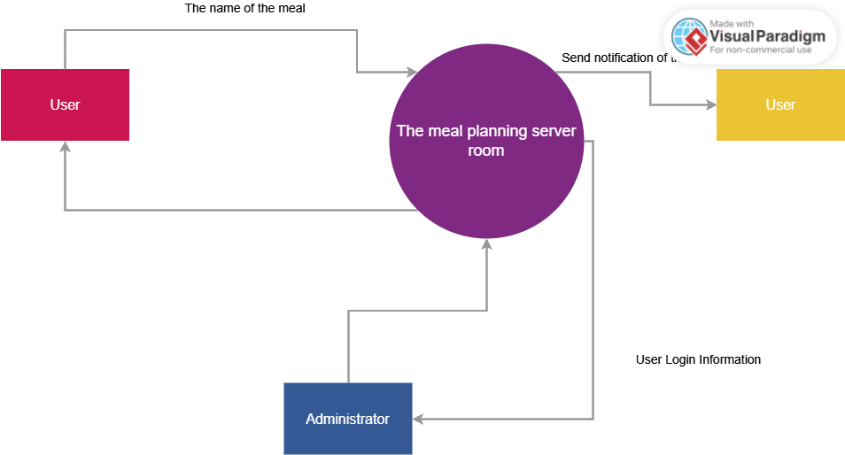

CONTEXT MODELS

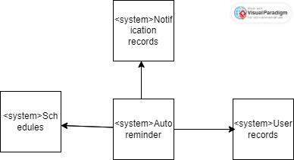

**STRUCTURAL MODELS**

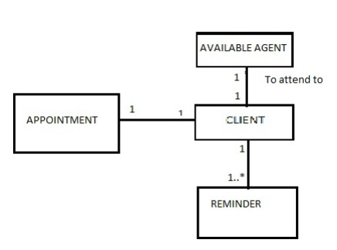

**BEHAVIOURAL MODEL**

**Aggregation association**

